Excel – Problem 1

- Excel Flow

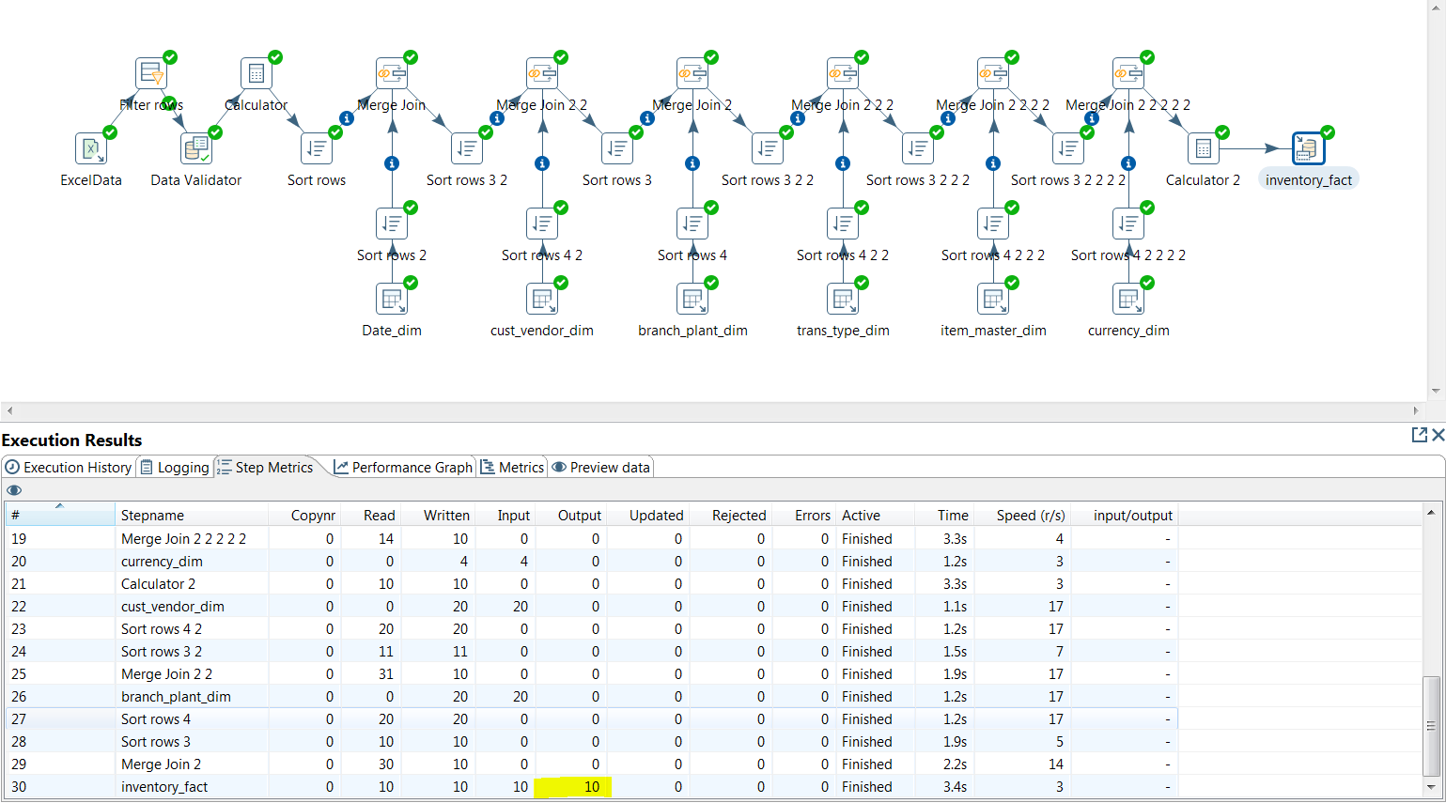

- Execution Flow result

- Insert / Update

